University of Cebu-Banilad

College of Computer Studies

# HEALTHSHAPERS

IT-ELDROID 1

84155 FRI (7:30 – 10:30 AM)

Submitted by:

Charles Brexie T. Saturinas

Jay Esplaguera

Dominic Restauro

Butch Nino Butas

Kevin Cachero

William James Janohan

IT-ELPHP

84193 SAT(7:30 – 10:30 AM)

Submitted by:

Charles Brexie T. Saturinas

Dominic Restauro

Jay Esplaguera (Alliance)

Jessalyn C. Sadili

Fretch Barbie H. Hugo

Submitted to:

Mr. Richyll Son

**HealthShapers Project Documents**

**HealthShapers:** Is an innovative food donation application designed to bridge the gap between surplus food and those in need. Our platform connects businesses, restaurants, and individuals looking to donate excess food with local charities and food banks.

# ERD

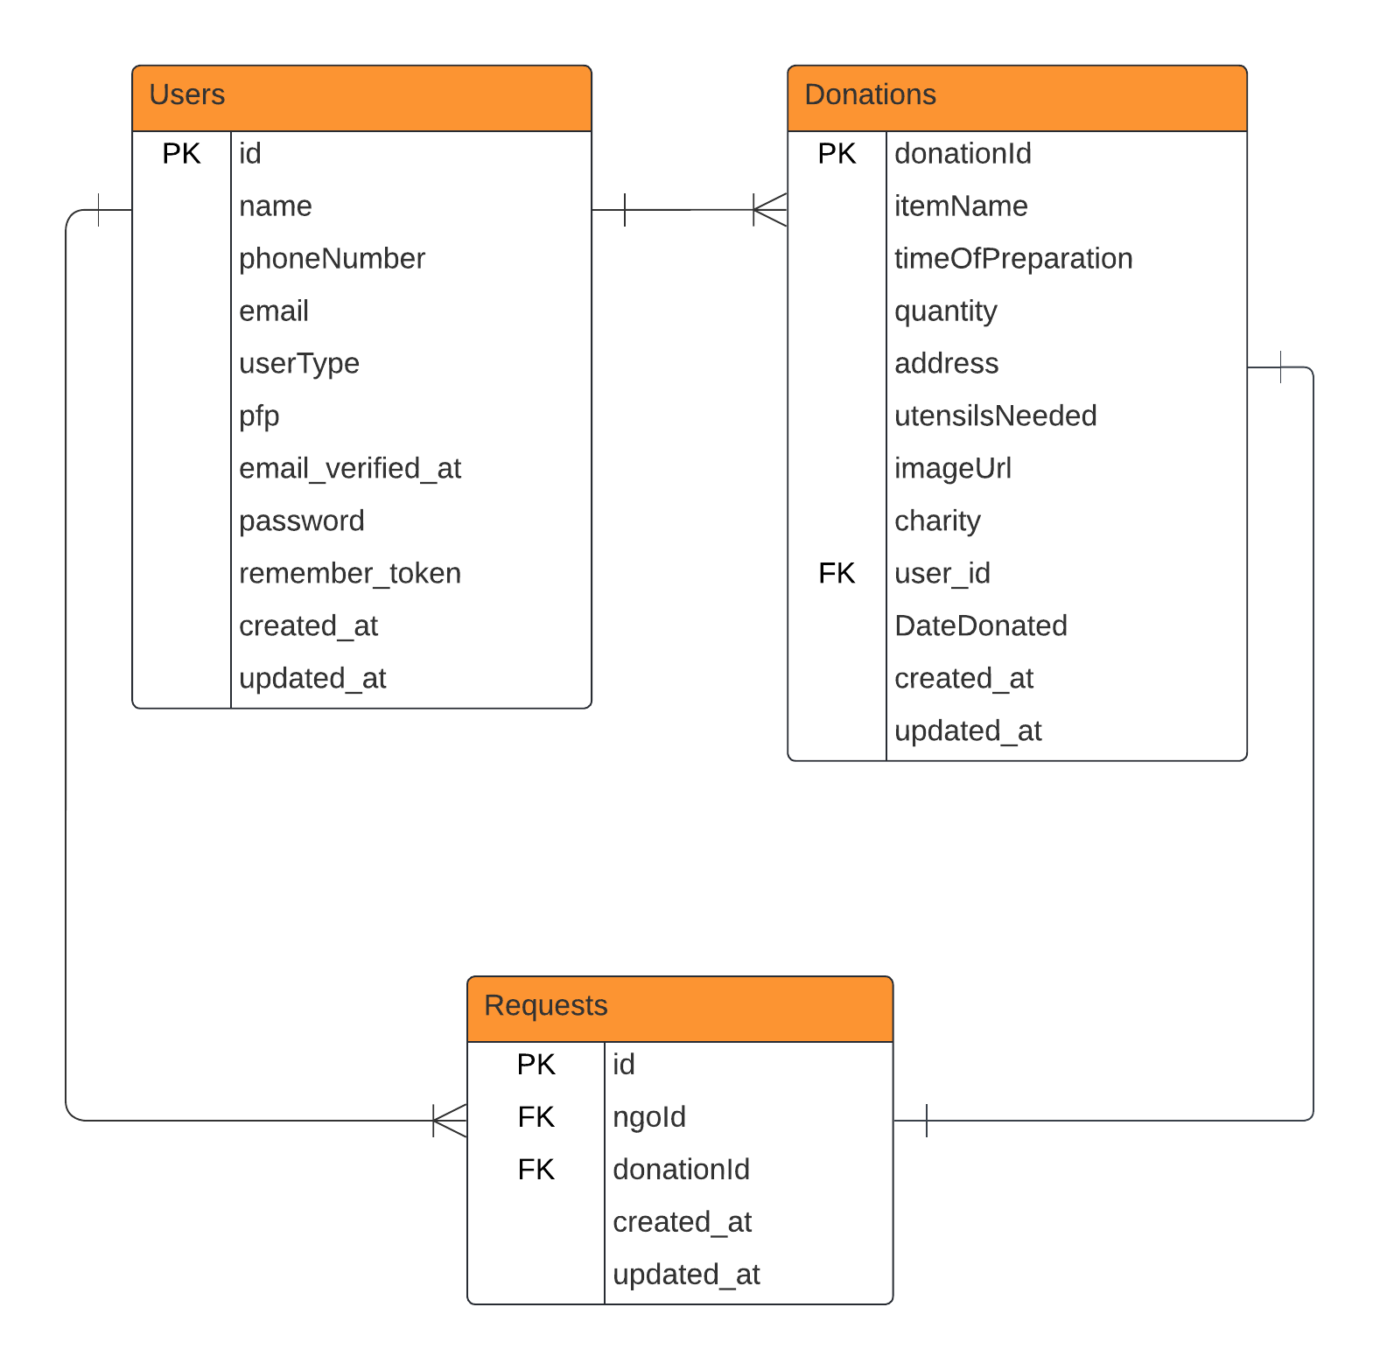

# **Use Case Diagram**

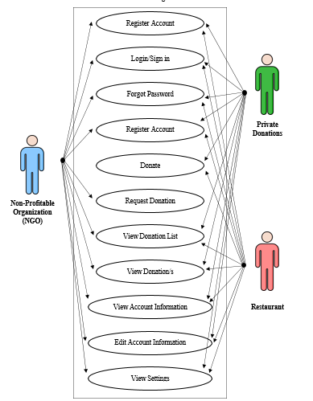

# 

# Figure 2: The Health Shapers use case diagram illustrates the interactions between key actors—NGOs/Food Banks, Restaurants, and Private Donations—within the system. NGOs/Food Banks view available donations, request or claim food, and confirm receipt. They can also manage donation history and leave feedback for donors. Restaurants and Private Donations can register, log in, list surplus food for donation, and coordinate pickups, while receiving notifications on donation status.

# 

# 

# 

# 

# 

# 

# Database Design

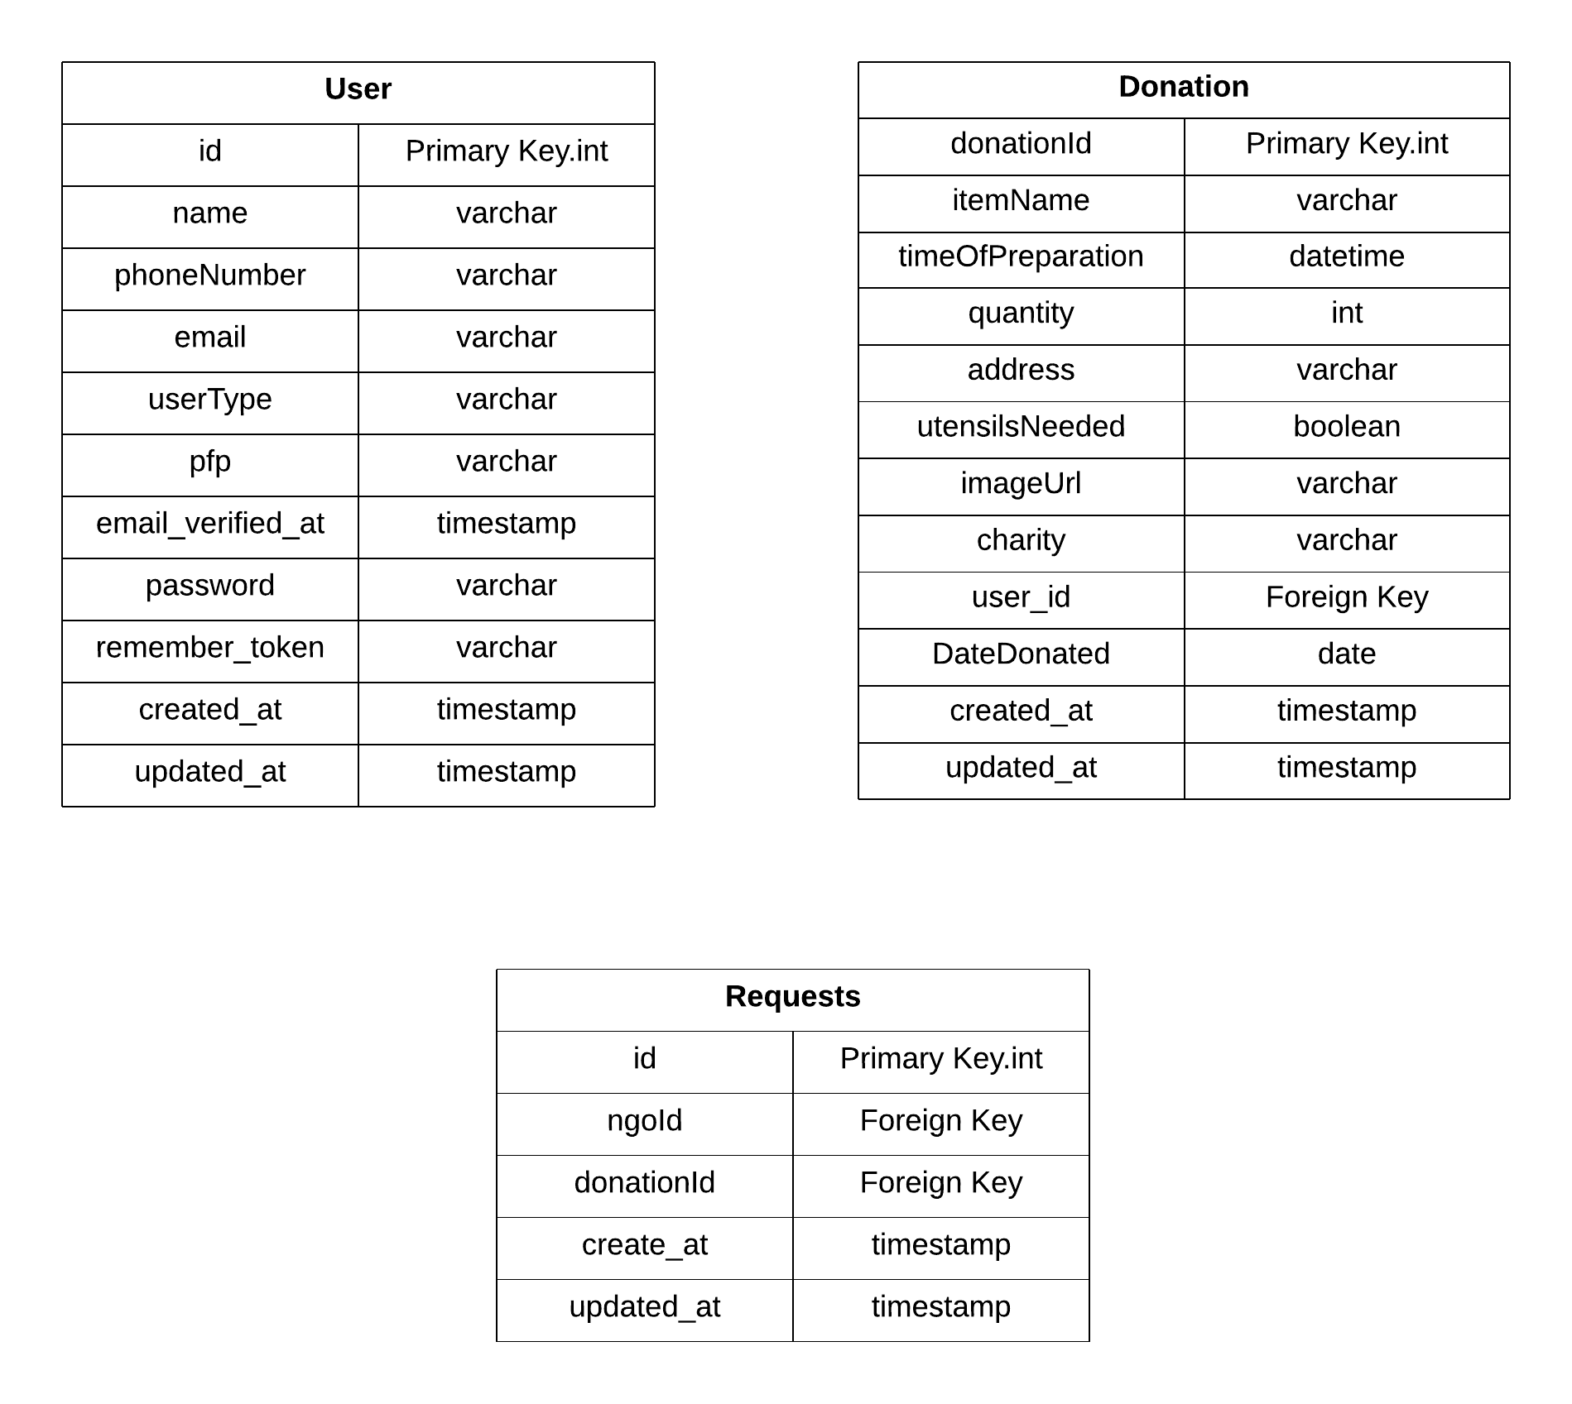

# 

# **UI DESIGN**

| **Splash Screen** | | |
| --- | --- | --- |
|  | | |
|
|
|
|
|
|
|
|
|
|
|
| **Name** | **Description** | **Parameter** |
| App Logo | HealthShapers app logo | src (image path) |

| **Login Screen** | | |
| --- | --- | --- |
|  | | |
|
|
|
|
|
|
|
|
|
|
|
| **Name** | **Description** | **Parameter** |
| App Logo | HealthShapers app logo | image |
| Login Text | Login word text display | text |
| Email Input | Login input edit text | email |
| Password Input | Password input edit text | password |
| Remember me checkbox | Clickable for automatically filling out the Login input and password input | checked |
| Forgot Password | Clickable forgot password text display | new password |
| Login Button | Signing in the user to use the application features | login action |
| Don’t have an account? Sign up | Clickable for registering an account | text |

| **Register Screen** | | |
| --- | --- | --- |
|  | | |
|
|
|
|
|
|
|
|
|
|
|
| **Name** | **Description** | **Parameter** |
| Register Text | Register word text display | text |
| Username Input | Username input edit text display | Username |
| Cell Phone Number Input | Cell Phone number input edit text display | Phone Number |
| Email Input | Email input edit text display | Email |
| Password Input | Password input edit text display | Password |
| Register Button | Registers the user with the form information | Button |
| Already have an account? Sign in | Clickable for directing the user to the login screen | Button |

| **Forgot Password Screen** | | |
| --- | --- | --- |
|  | | |
|
|
|
|
|
|
|
|
|
|
|
| **Name** | **Description** | **Parameter** |
| Forgot Password Text | Forgot password text display | text |
| Email Address Input | Email address input edit text | Email |
| Send link button | Clickable for sending information to the email | Button |

| **NGO Dashboard Screen** | | |
| --- | --- | --- |
|  | | |
|
|
|
|
|
|
|
|
|
|
|
| **Name** | **Description** | **Parameter** |
| Food Image | Default image for dashboard | image |
| Hello! Need food? | Greetings text | text |
| Your Requests | Button to view donation requests | button |

| **NGO Donations List** | | |
| --- | --- | --- |
|  | | |
|
|
|
|
|
|
|
|
|
|
|
| **Name** | **Description** | **Parameter** |
| Food Image | Image of the Donation | image |
| Item Name | Name of the item donated | text |
| Time of Preparation | Time the food was prepared | datetime |
| Quantity | Number of item to be donated | int |
| Address | Location where the donation will be dropped off or picked up | string |
| Utensils Needed | Utensils needed if they need utensils | input[type="radio"] |
| Charity | Name of the Charity | text |
| Donation ID | A unique identifier for each donation | int |

| **NGO Requests** | | |
| --- | --- | --- |
|  | | |
|
|
|
|
|
|
|
|
|
|
|
| **Name** | **Description** | **Parameter** |
| Requests Text | Requests Text Display | text |
| Items List | List of donations requested |  |

| **Restaurant/Private Donation Dashboard** | | |
| --- | --- | --- |
|  | | |
|
|
|
|
|
|
|
|
|
|
|
| **Name** | **Description** | **Parameter** |
| Food Image | Default Image in the dashboard | text |
| Hello! Want to share food? | Greetings text | text |
| Donate Button | Clickable button to donate foods | button |
| Your Donations Button | Clickable button to view donations made | button |

| **Restaurant/Private Donation New Donation Screen** | | |
| --- | --- | --- |
|  | | |
| **Name** | **Description** | **Parameter** |
| Title Text | "Food Details" Title Text Display | text |
| Item Name Text Field | Input field for "Item Name" | input[type="text"] |
| Time of Preparation Text | Input field for "Time of Preparation" | input[type="text"] |
| Quantity Text | Input field for "Quantity" | input[type="number"] |
| Address Text | Input field for "Address" | input[type="text"] |
| Charity Dropdown | Dropdown to select charity item | select |
| Utensils Required Label | Label for "Utensils Required?" | label |
| Utensils Yes/No Option | Radio buttons to select "Yes" or "No" | input[type="radio"] |
| Add Photo Label | Label for adding a photo | input[type="radio"] |
| Add Photo Button | "+" button to upload a photo | text |
| Submit Button | Button to submit the donation | button[type="submit"] |

| **Restaurant/Private Donation Your Donations Screen** | | |
| --- | --- | --- |
|  | | |
| **Name** | **Description** | **Parameter** |
| Title Text | "Your Donations" Title Text Display | text |
| Item List | List of donation entries | ul or div |
| Item Icon | User icon displayed with each donation | src (icon image path) |
| Item Name Text | Display of "Item Name" | text |
| Time Text | Display of donation time | text |
| Quantity Text | Display of donation quantity | text |
| Address Text | Display of address | text |
| Utensils Required Status | Display of "Yes/No" utensils status | text |
| Status Text | Donation status (e.g., "Pending") | text |

| **Donation List Screen** | | |
| --- | --- | --- |
|  | | |
|
|
|
|
|
|
|
|
|
|
|
| **Name** | **Description** | **Parameter** |
| Item List | A detailed list of items donated |  |

| **Profile** | | |
| --- | --- | --- |
|  | | |
|
|
|
|
|
|
|
|
|
|
|
| **Name** | **Description** | **Parameter** |
| Profile | Profile Text | text |
| Profile Placeholder | Placeholder to place the image uploaded | image |
| Username Input | Editable input field for Username | input[type=”text] |
| Phone Number Input | Editable input field for Phone Number | input[type=”text] |
| Email Address Input | Editable input field for Email Address | input[type=”text] |

| **Settings** | | |
| --- | --- | --- |
|  | | |
| **Name** | **Description** | **Parameter** |
| Title Text | “Settings” Text Display | text |
| User Avatar | Placeholder User Profile Image | src (image path) |
| About Us Text Field | Clickable “About Us” Text Display | button |
| About Us Icon | Star Icon Display | src (icon image path) |
| Terms Text Field | Clickable “Terms and Conditions” Text Display | button |
| Terms Icon | Document Icon Display | src (icon image path) |
| Log Out Text Field | Clickable “Log Out” Text Display | button |
| Log Out Icon | Logout Icon Display | src (icon image path) |

# Sequence Diagram

**RESTAURANT/PRIVATE DONATION**

User Registration and Role Selection

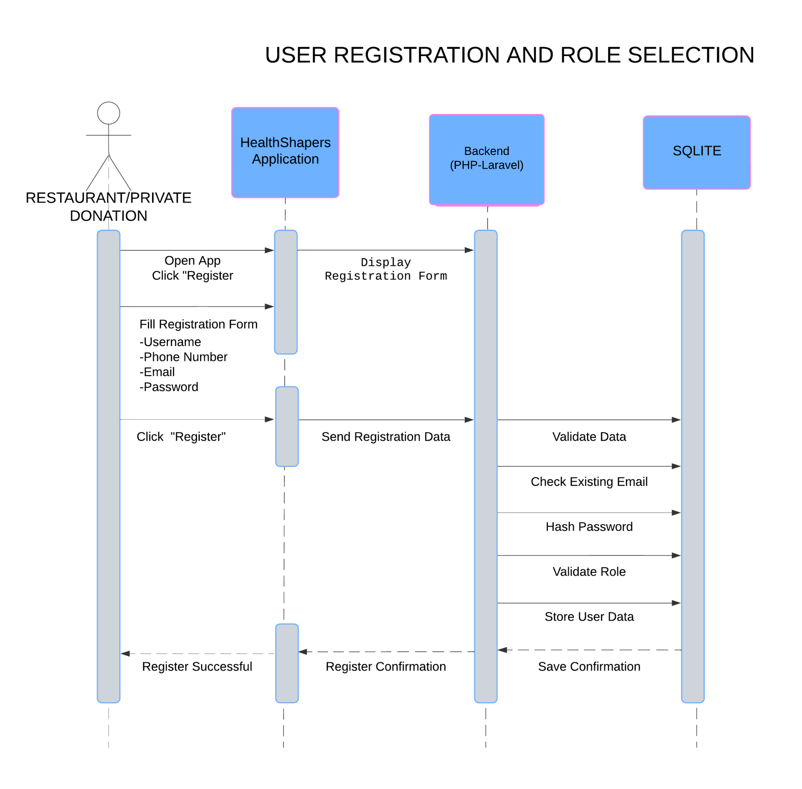

Login Process

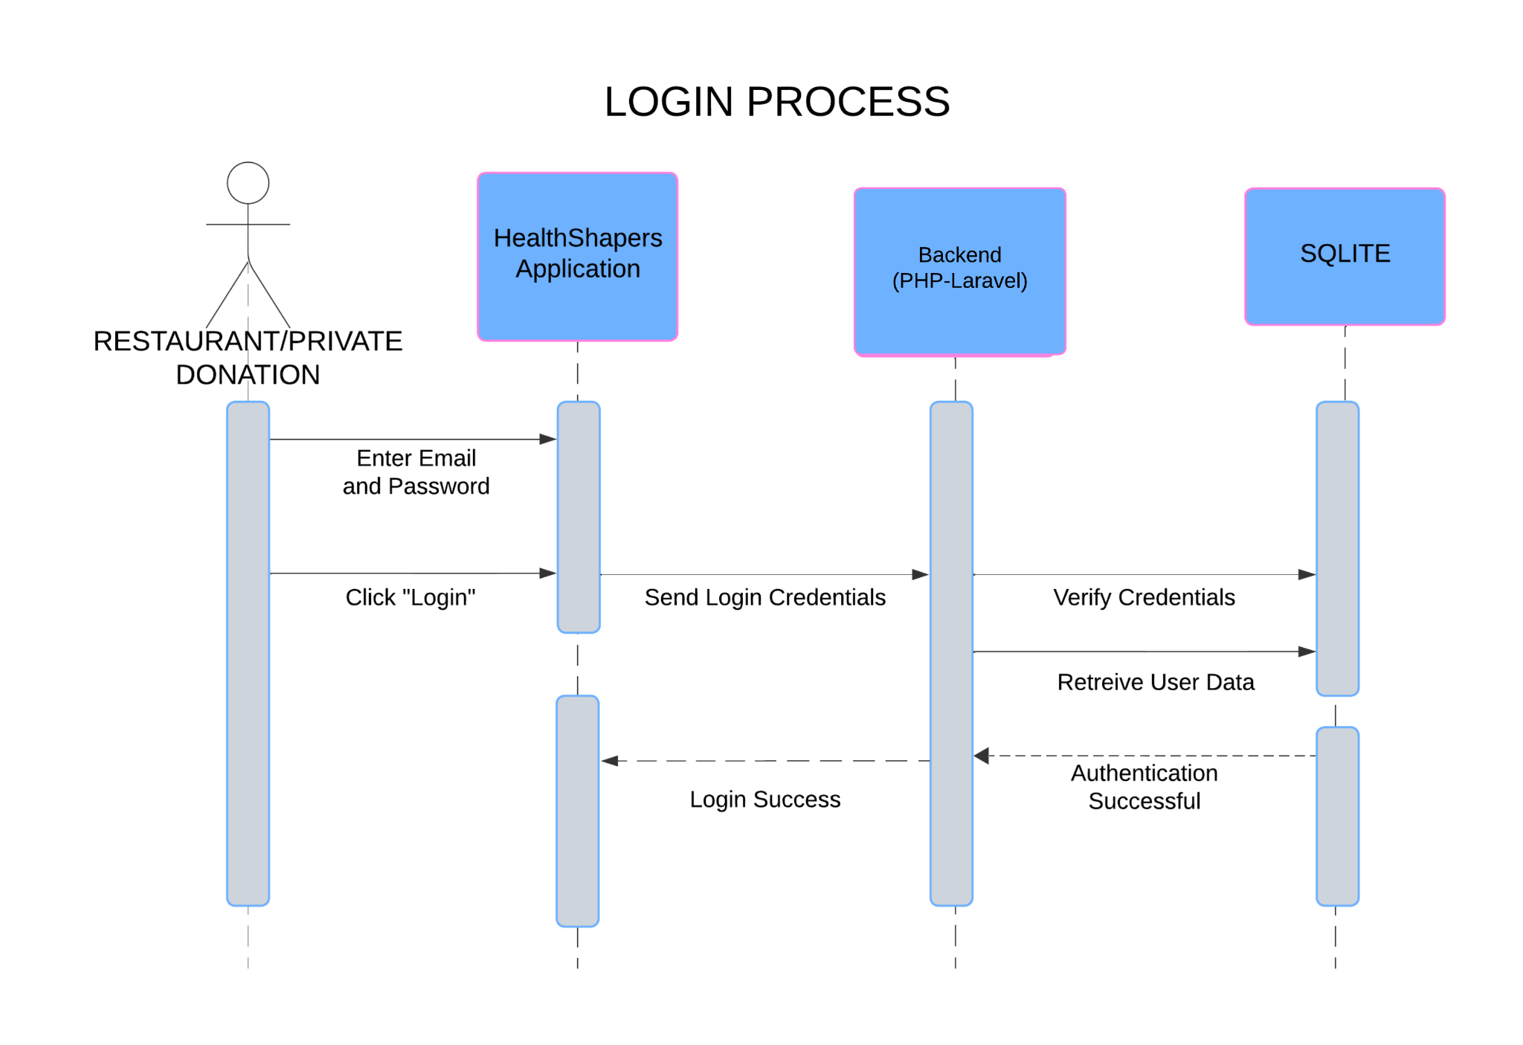

Creating a New Donation

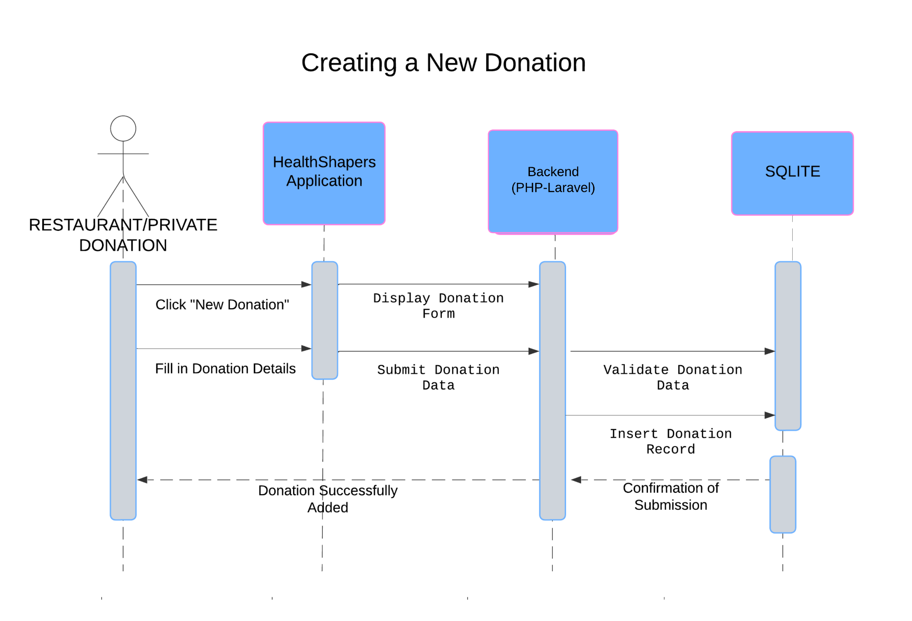

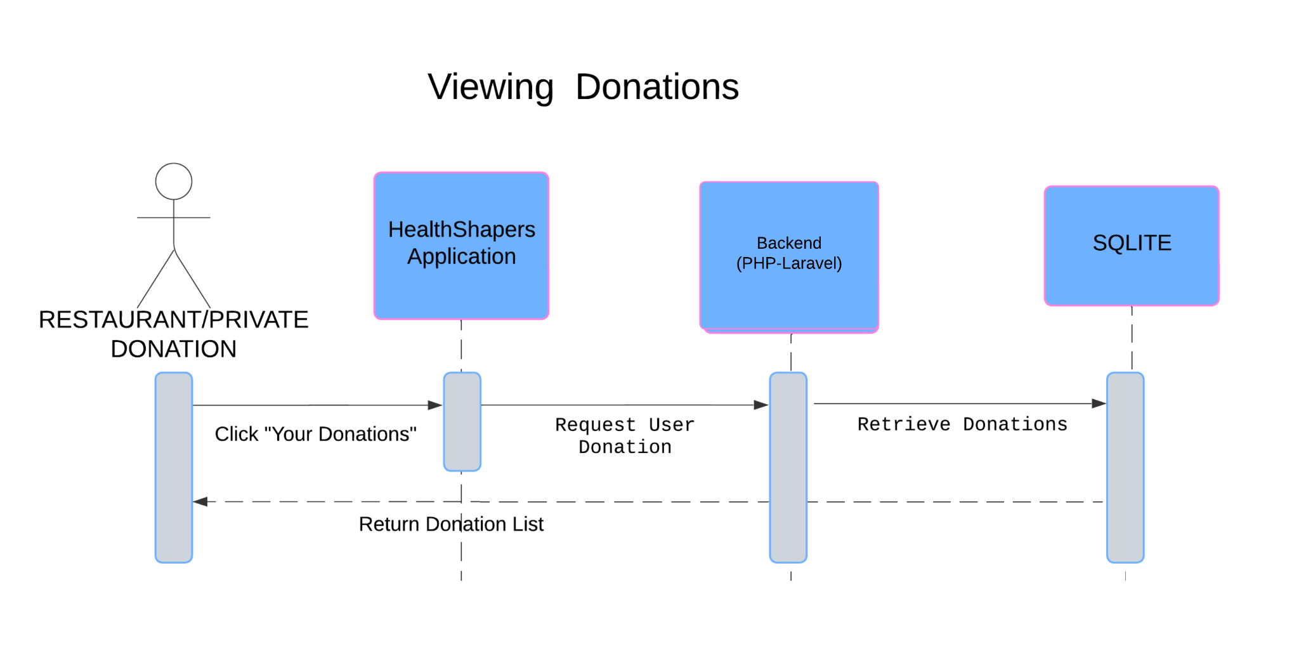

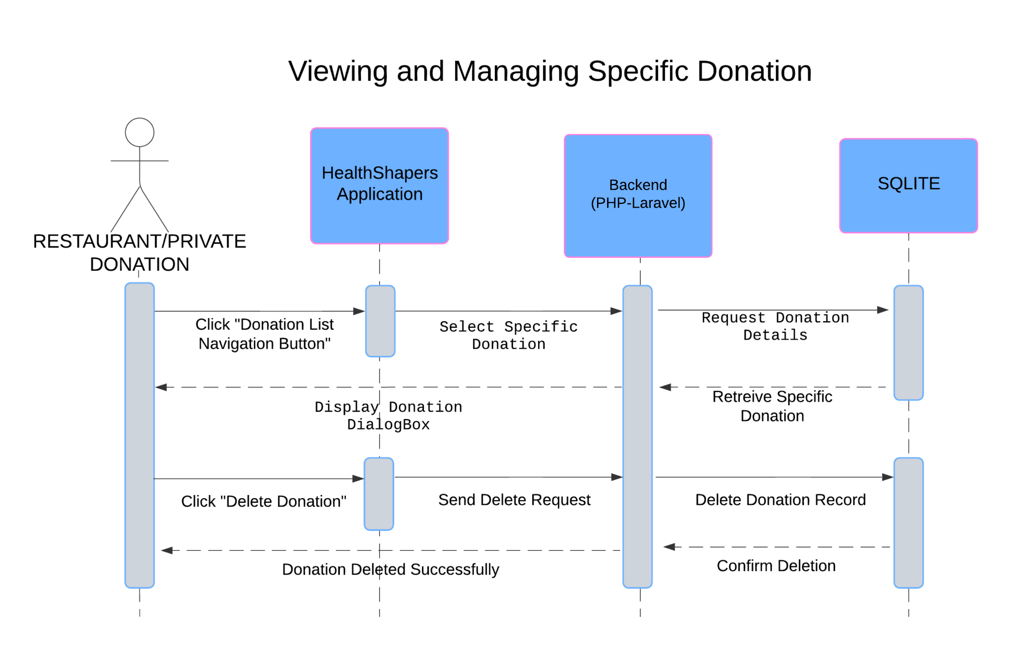

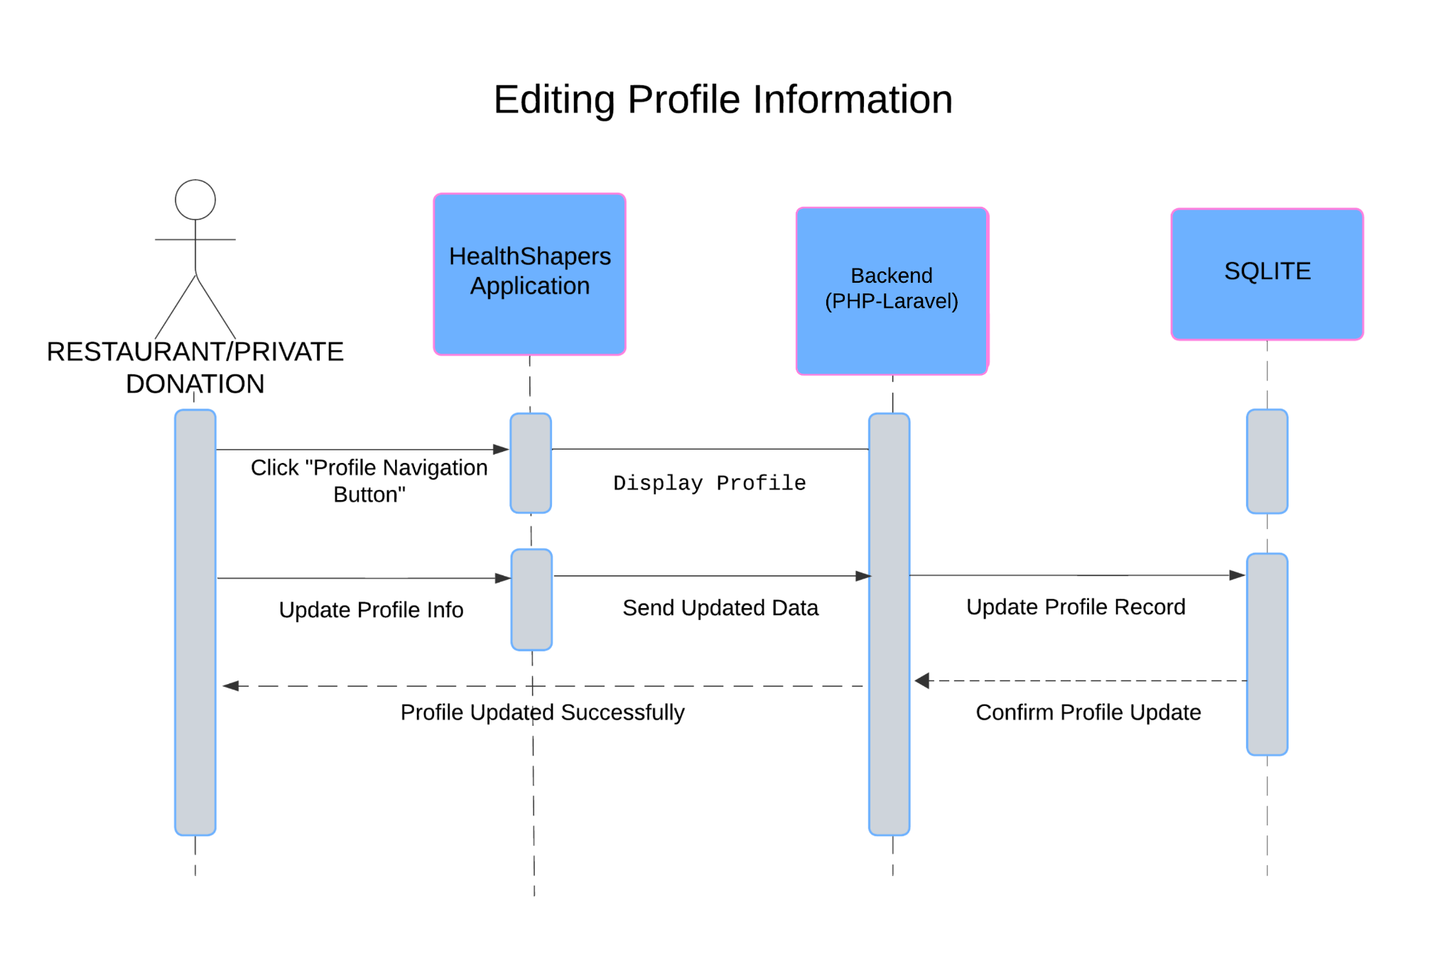

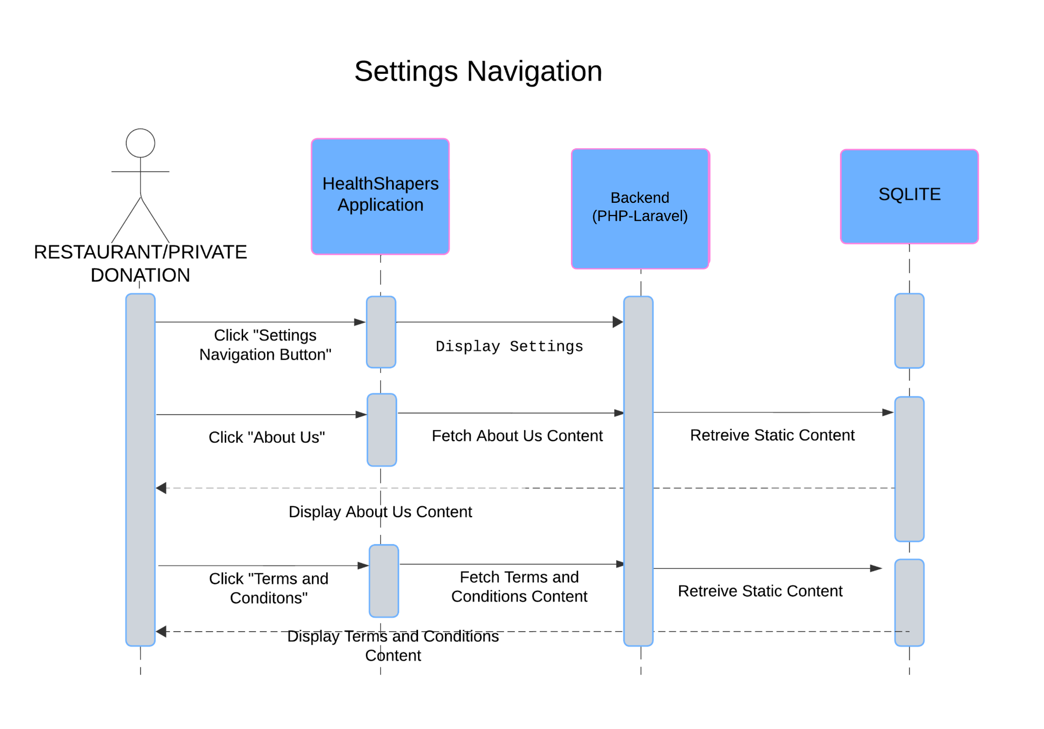

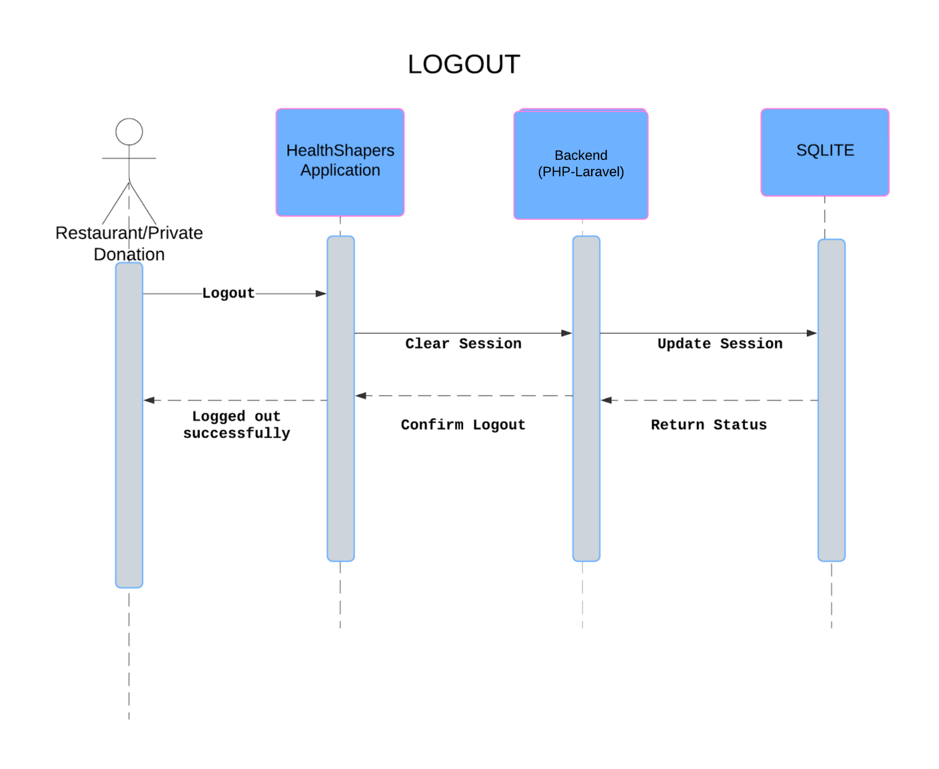

**NGO**

Register

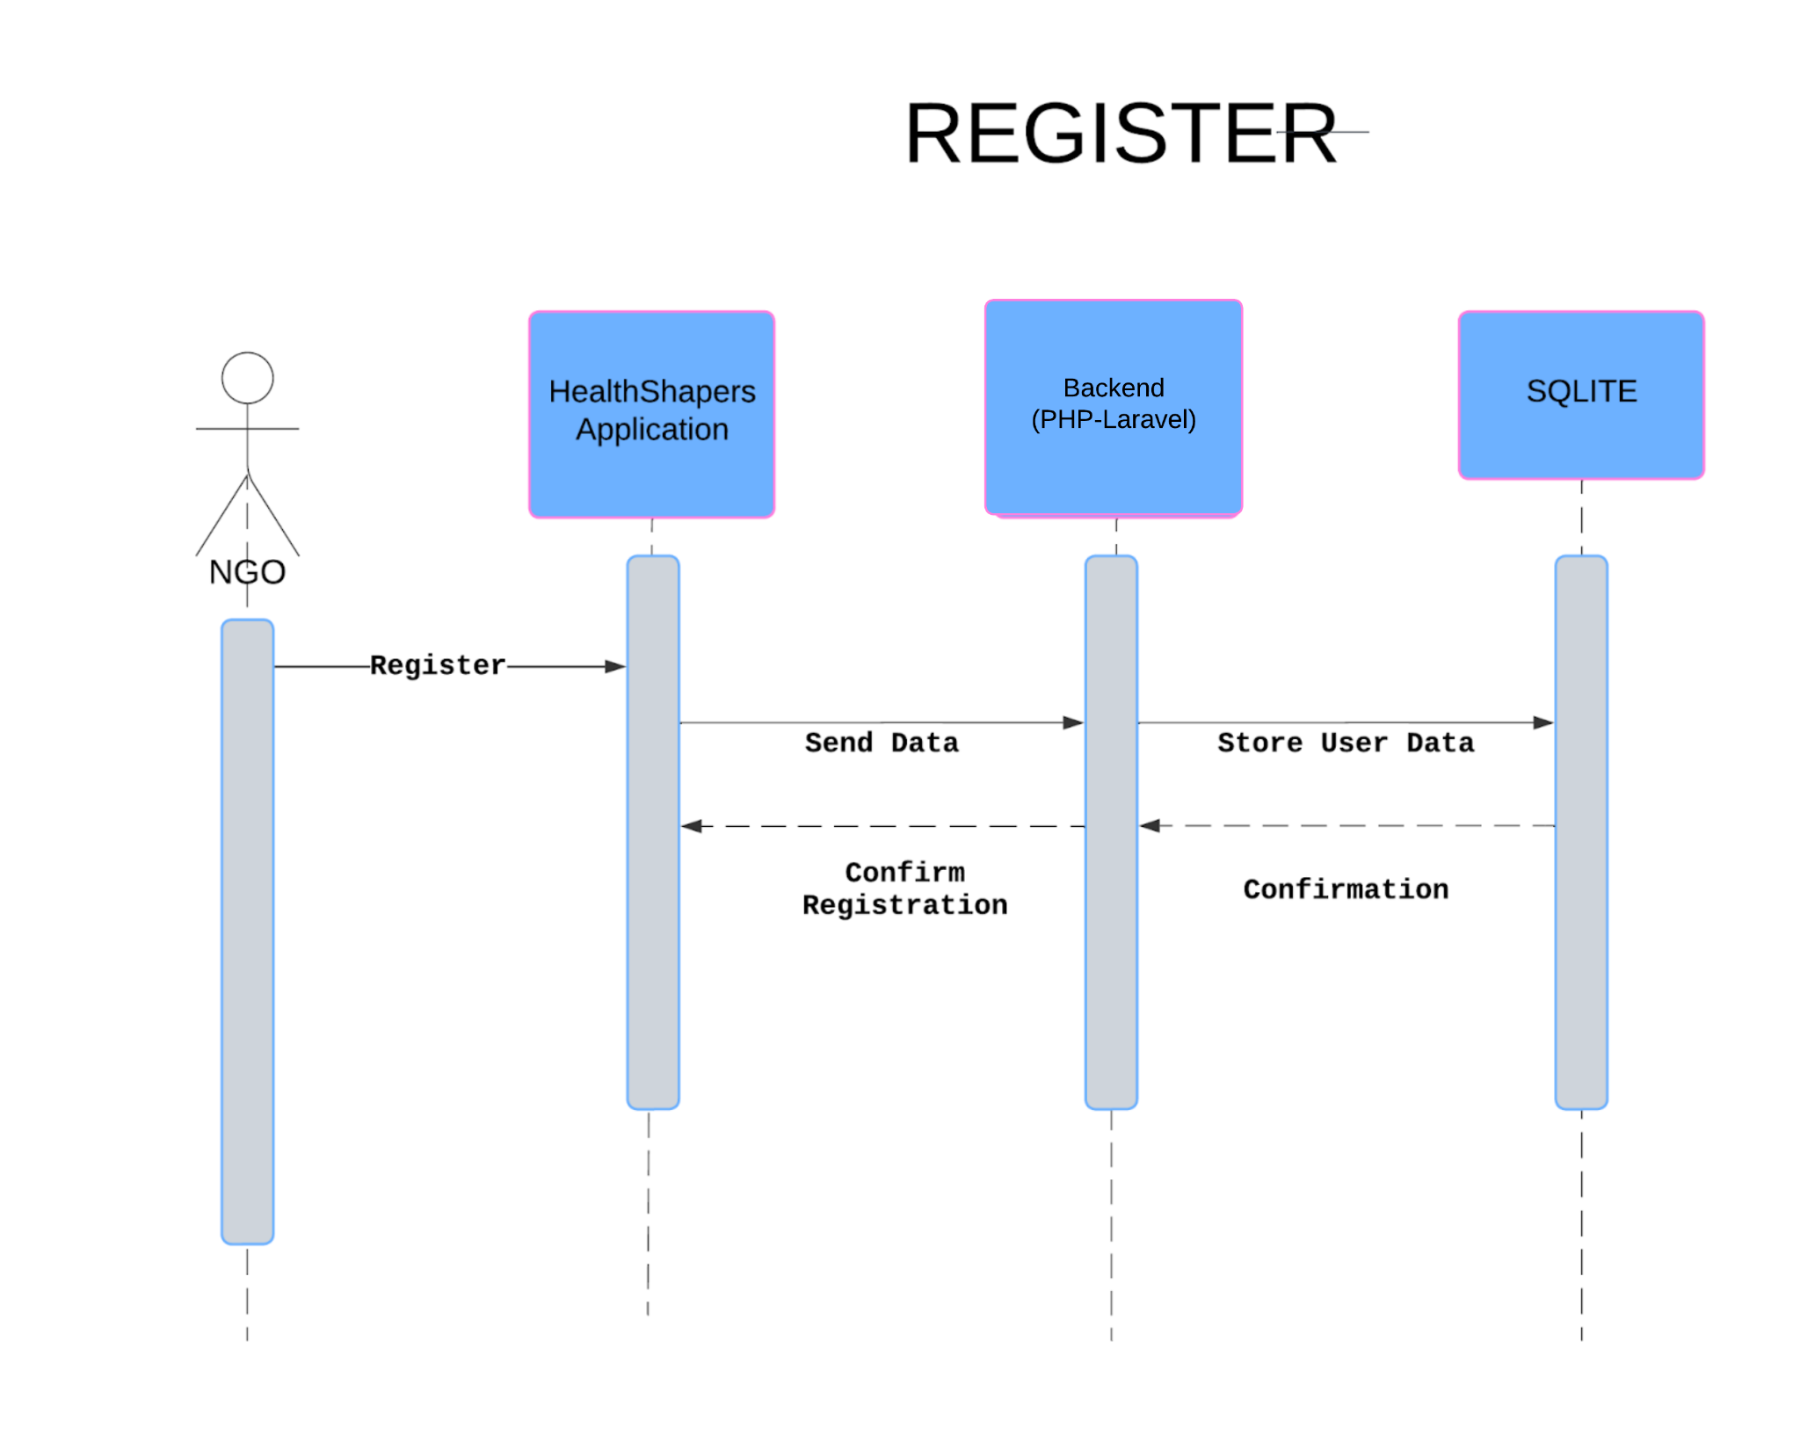

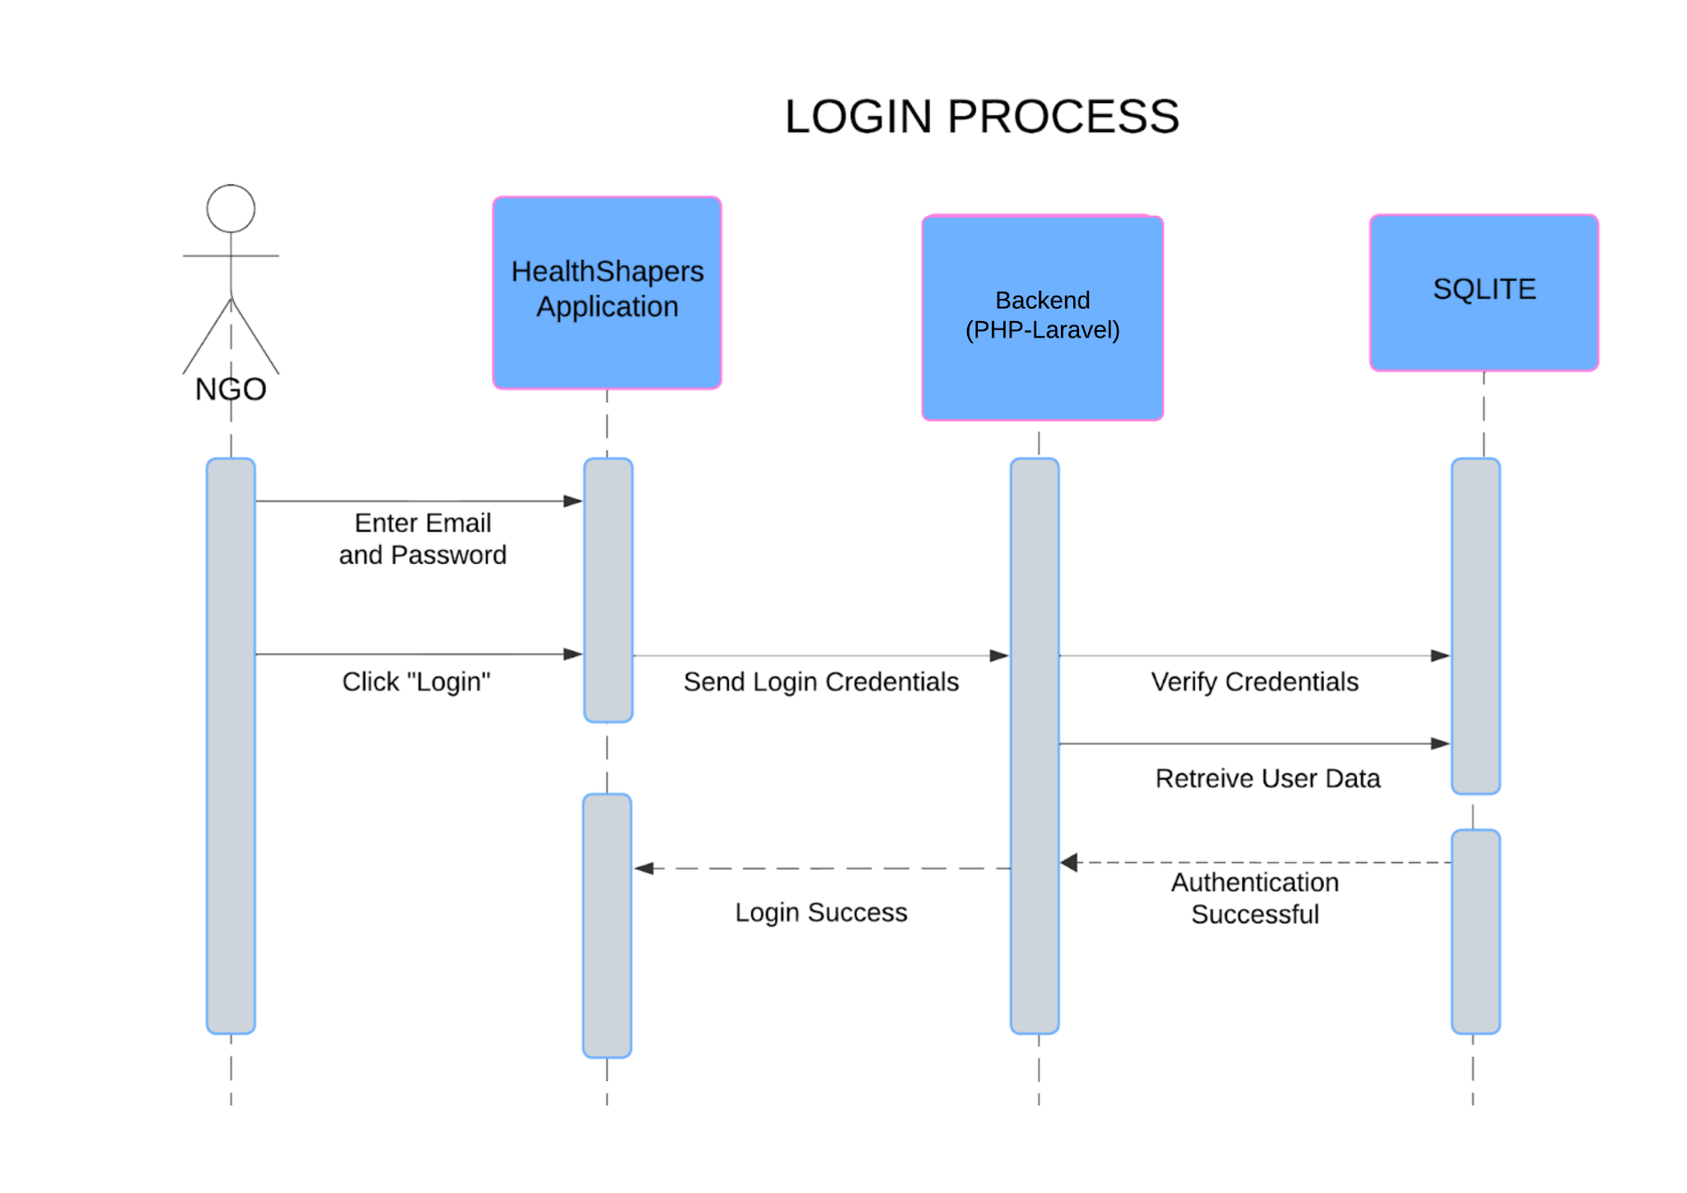

Dashboard

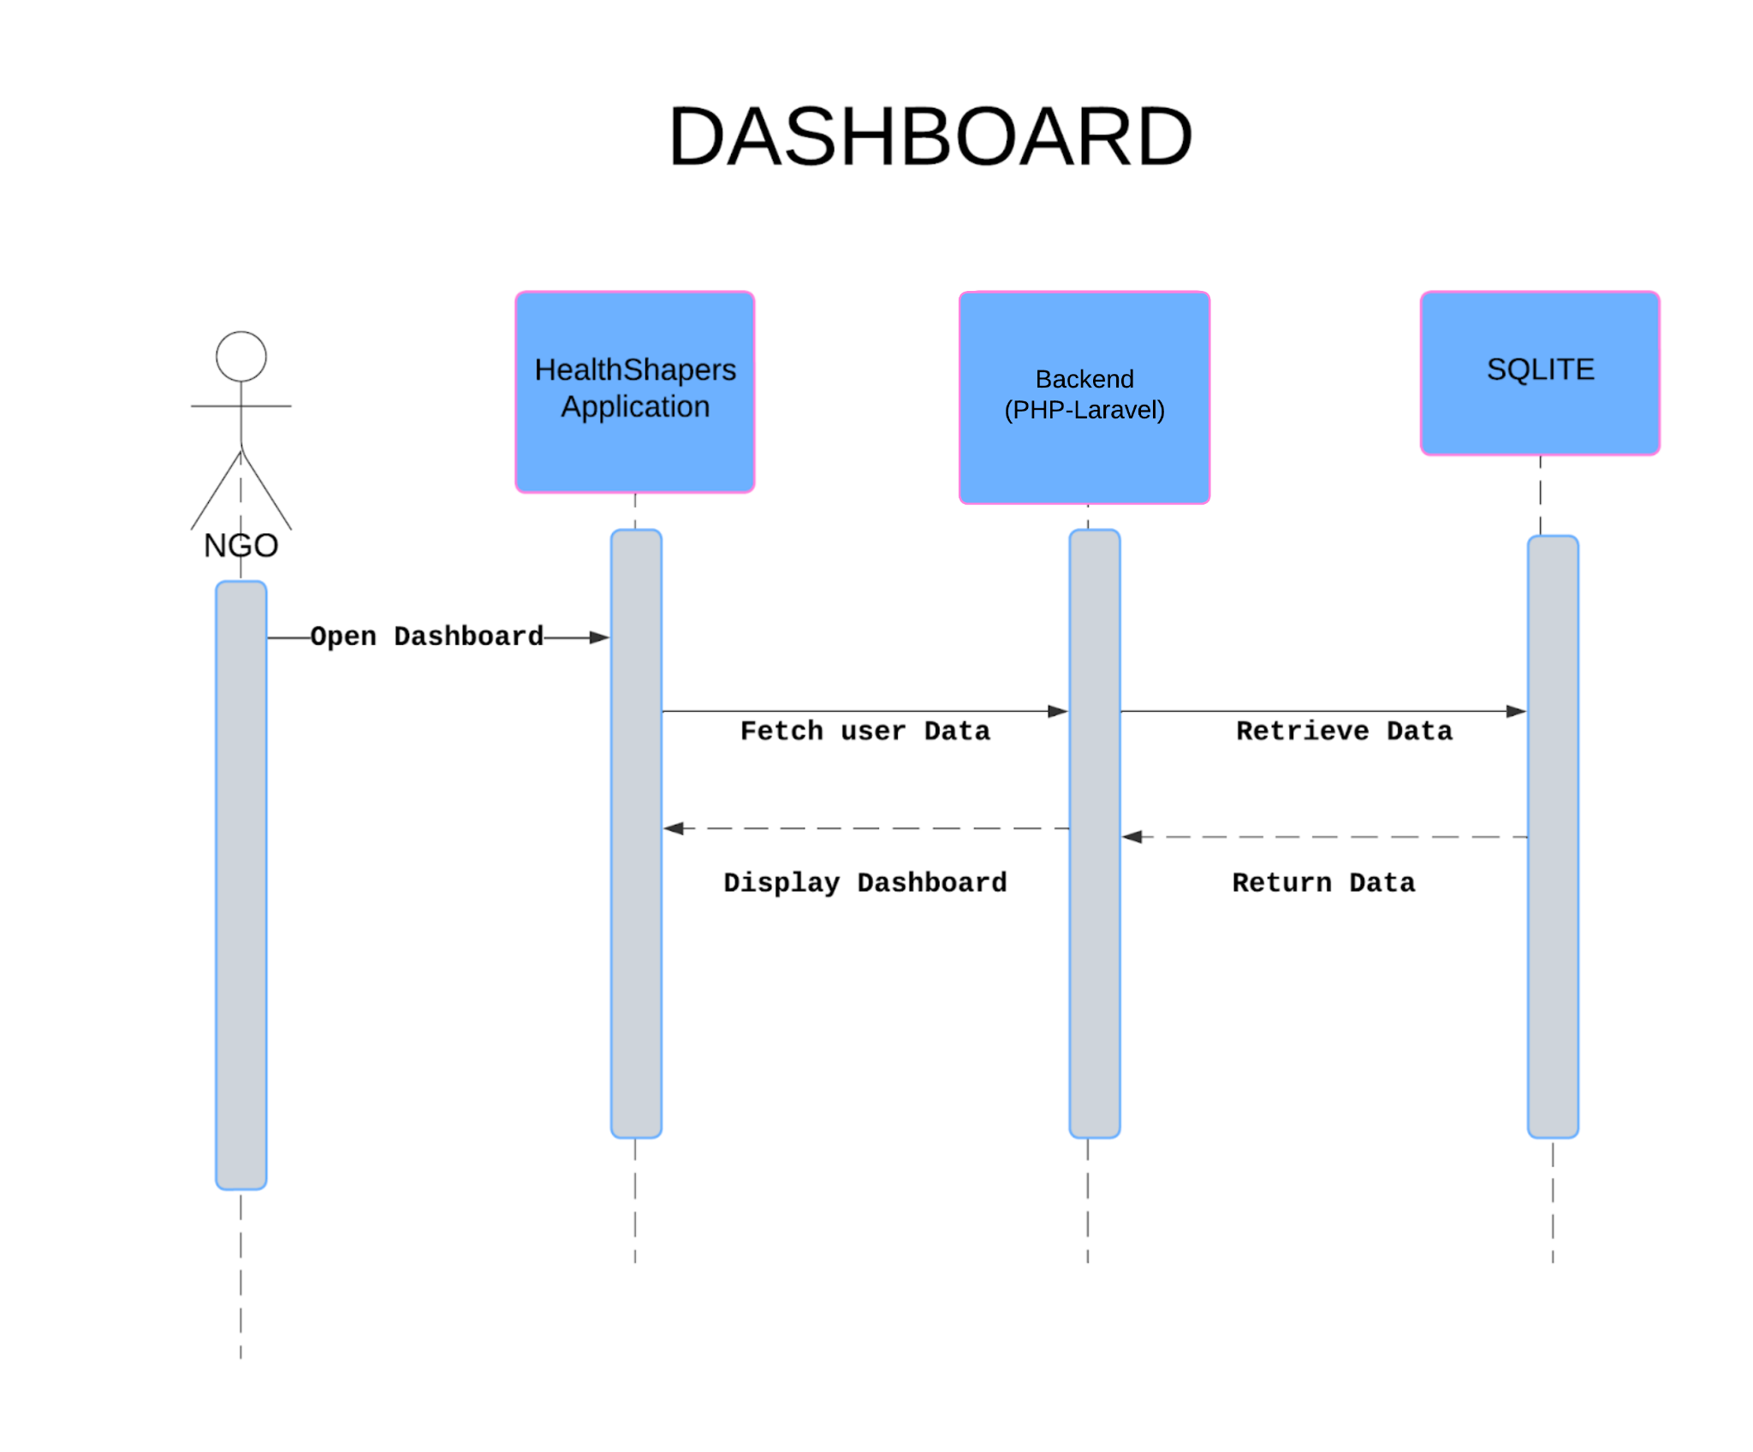

View Donations

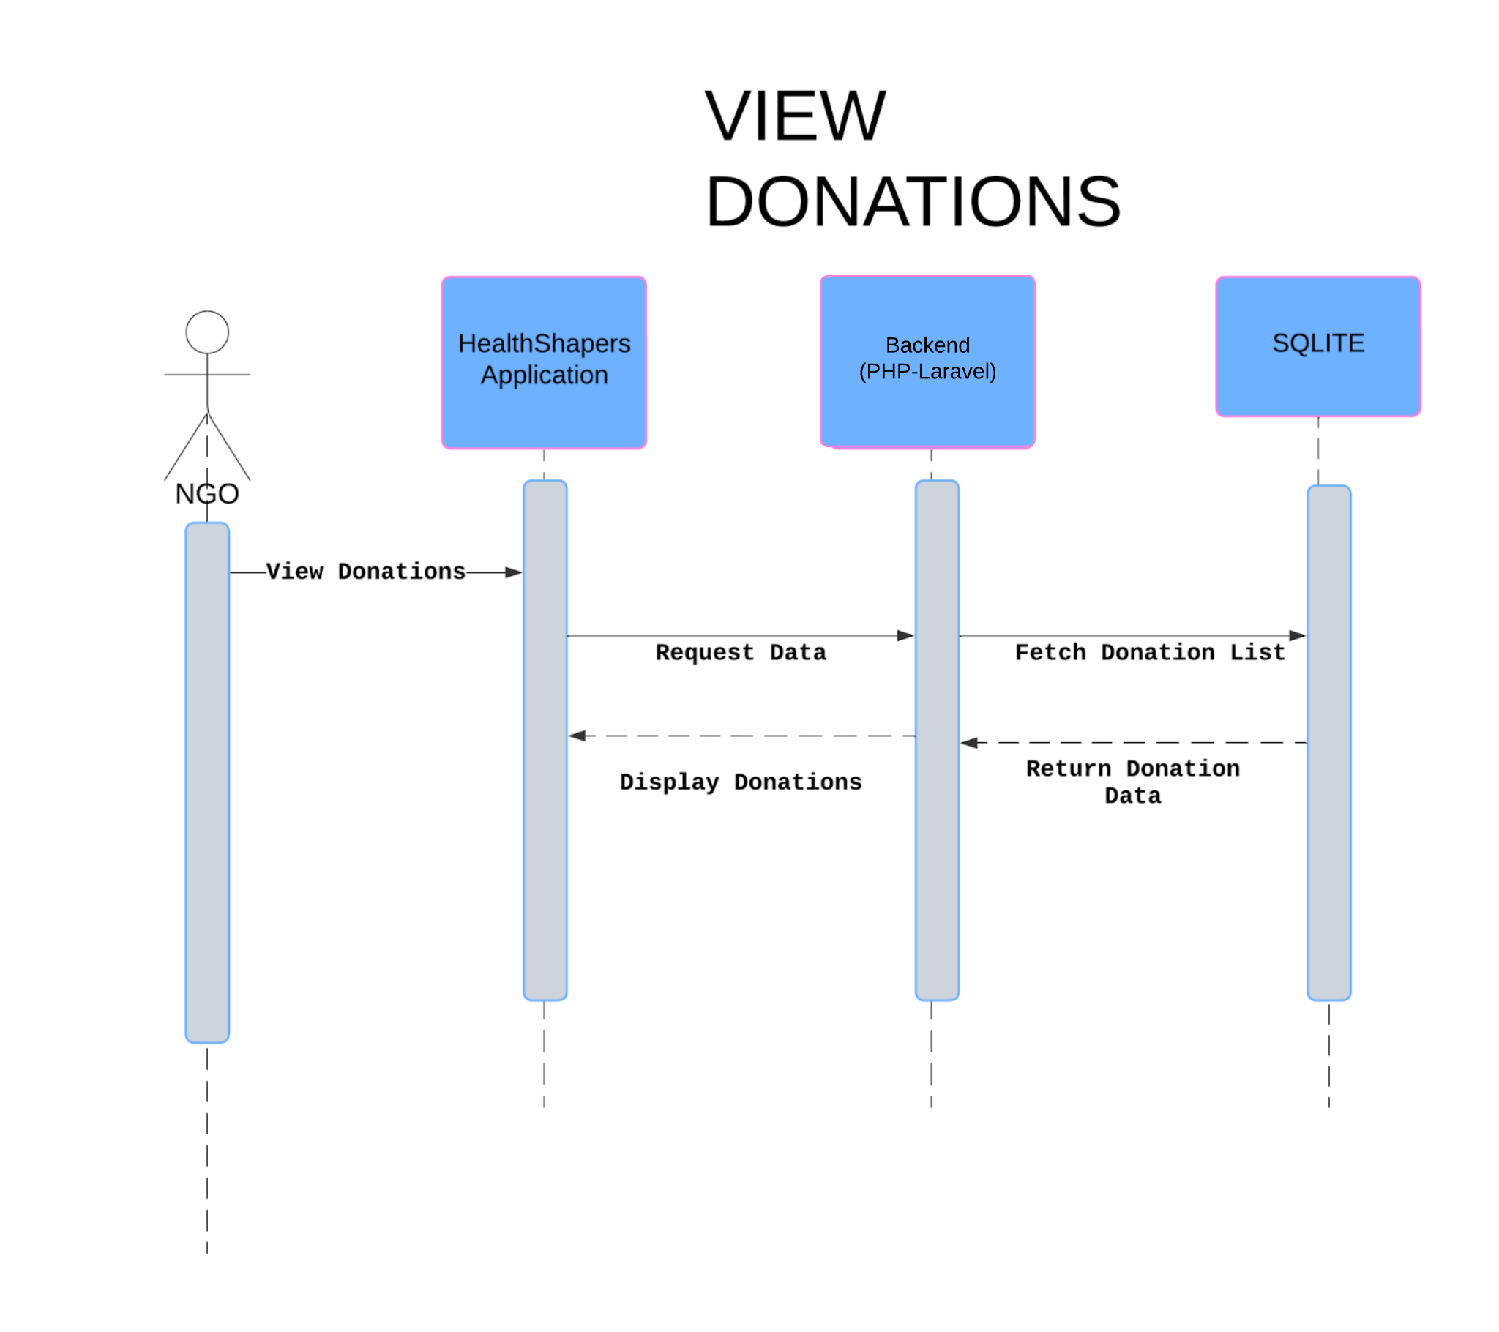

Select Donation

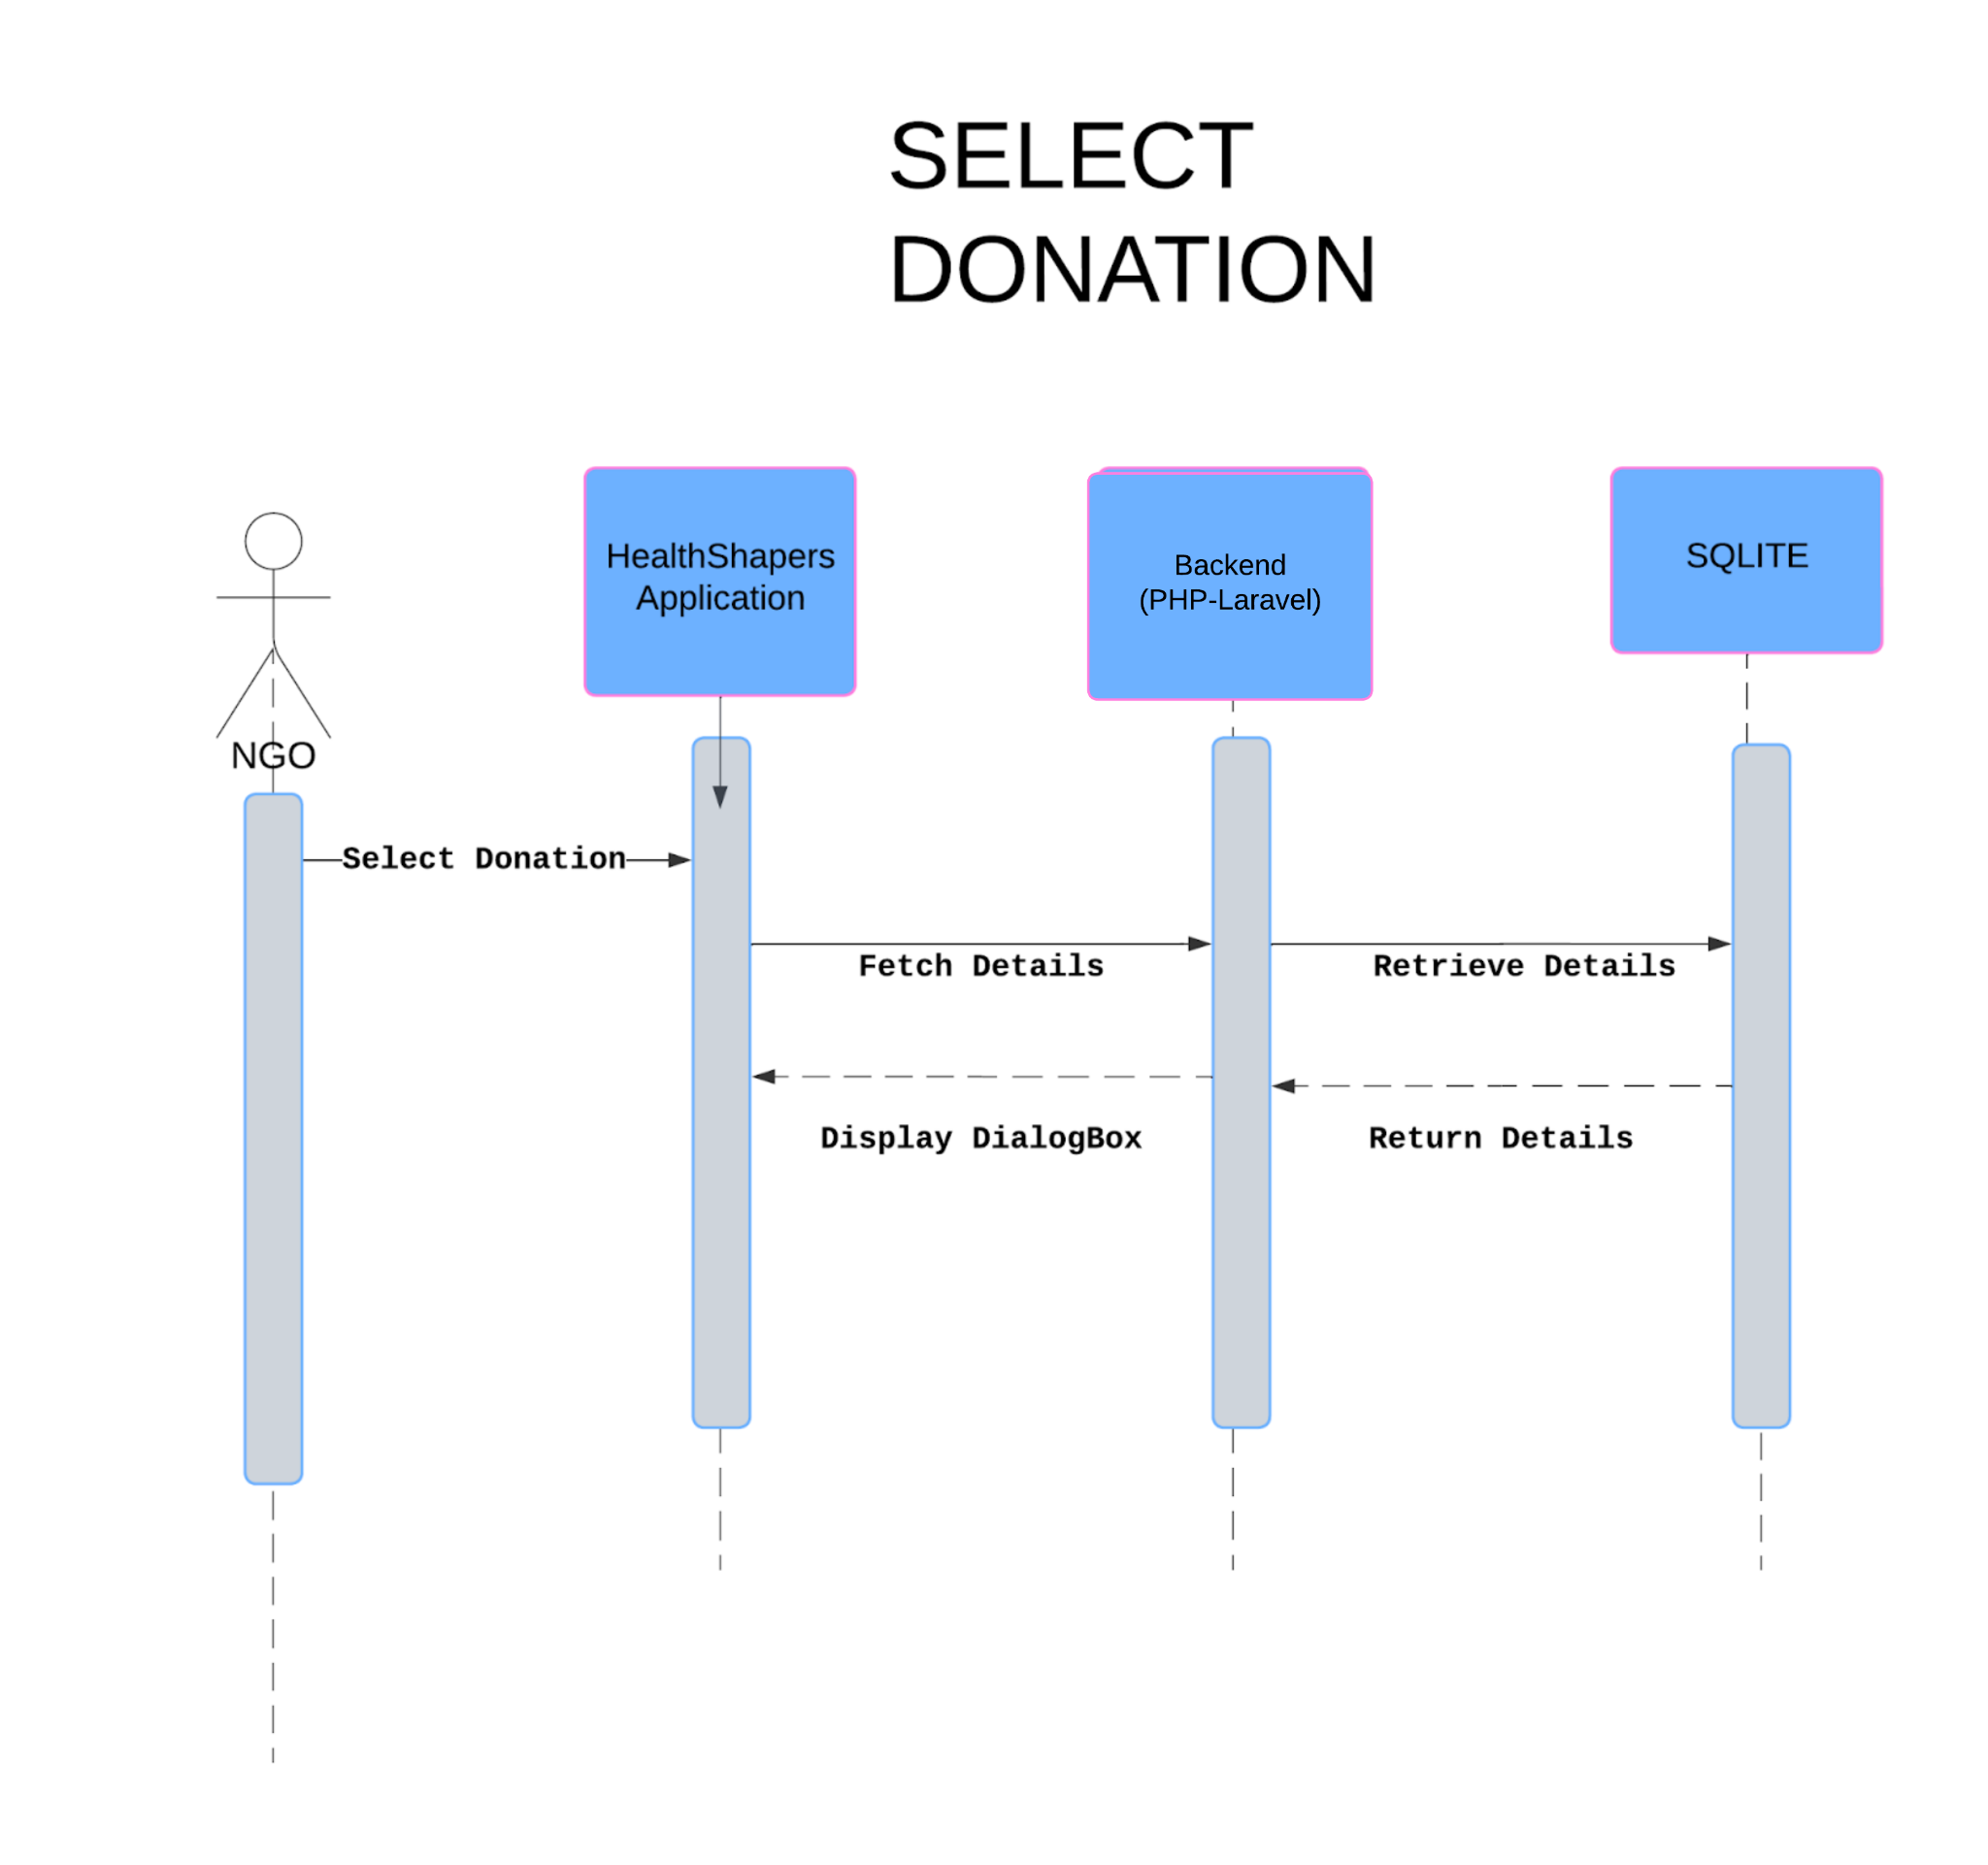

Your Requests

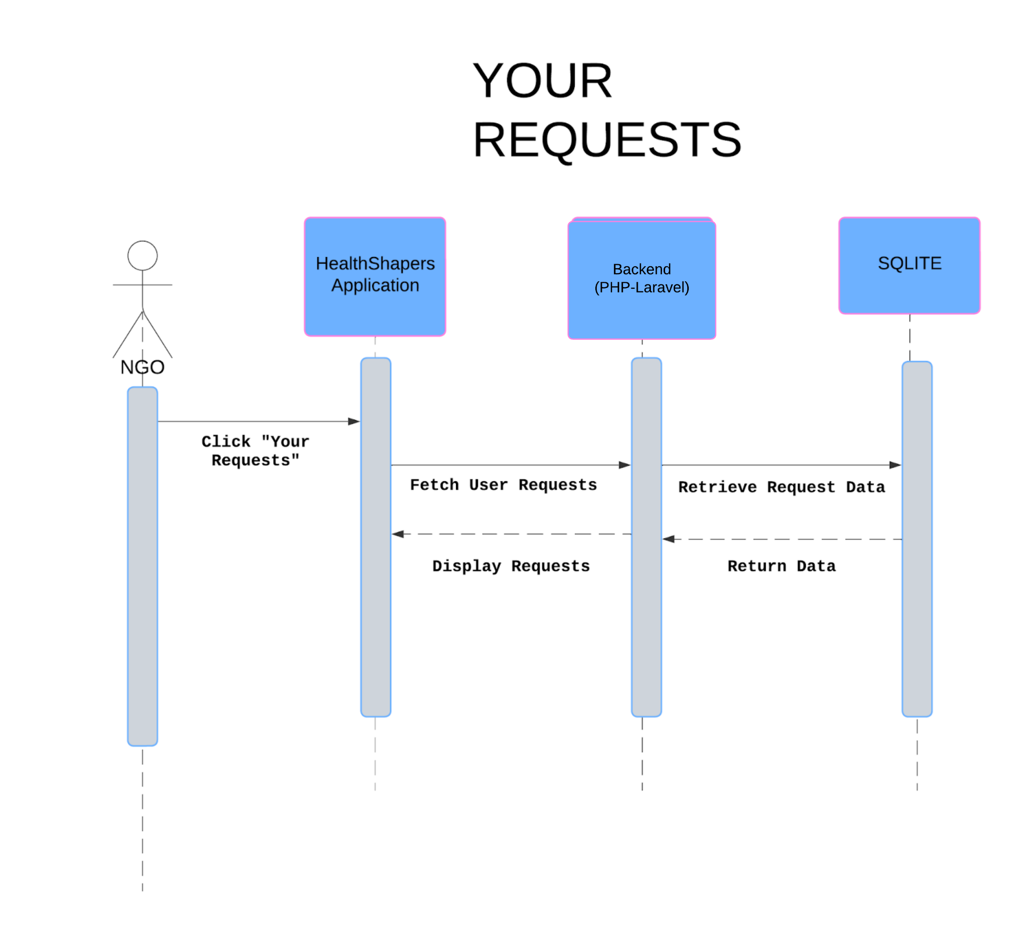

Edit Profile

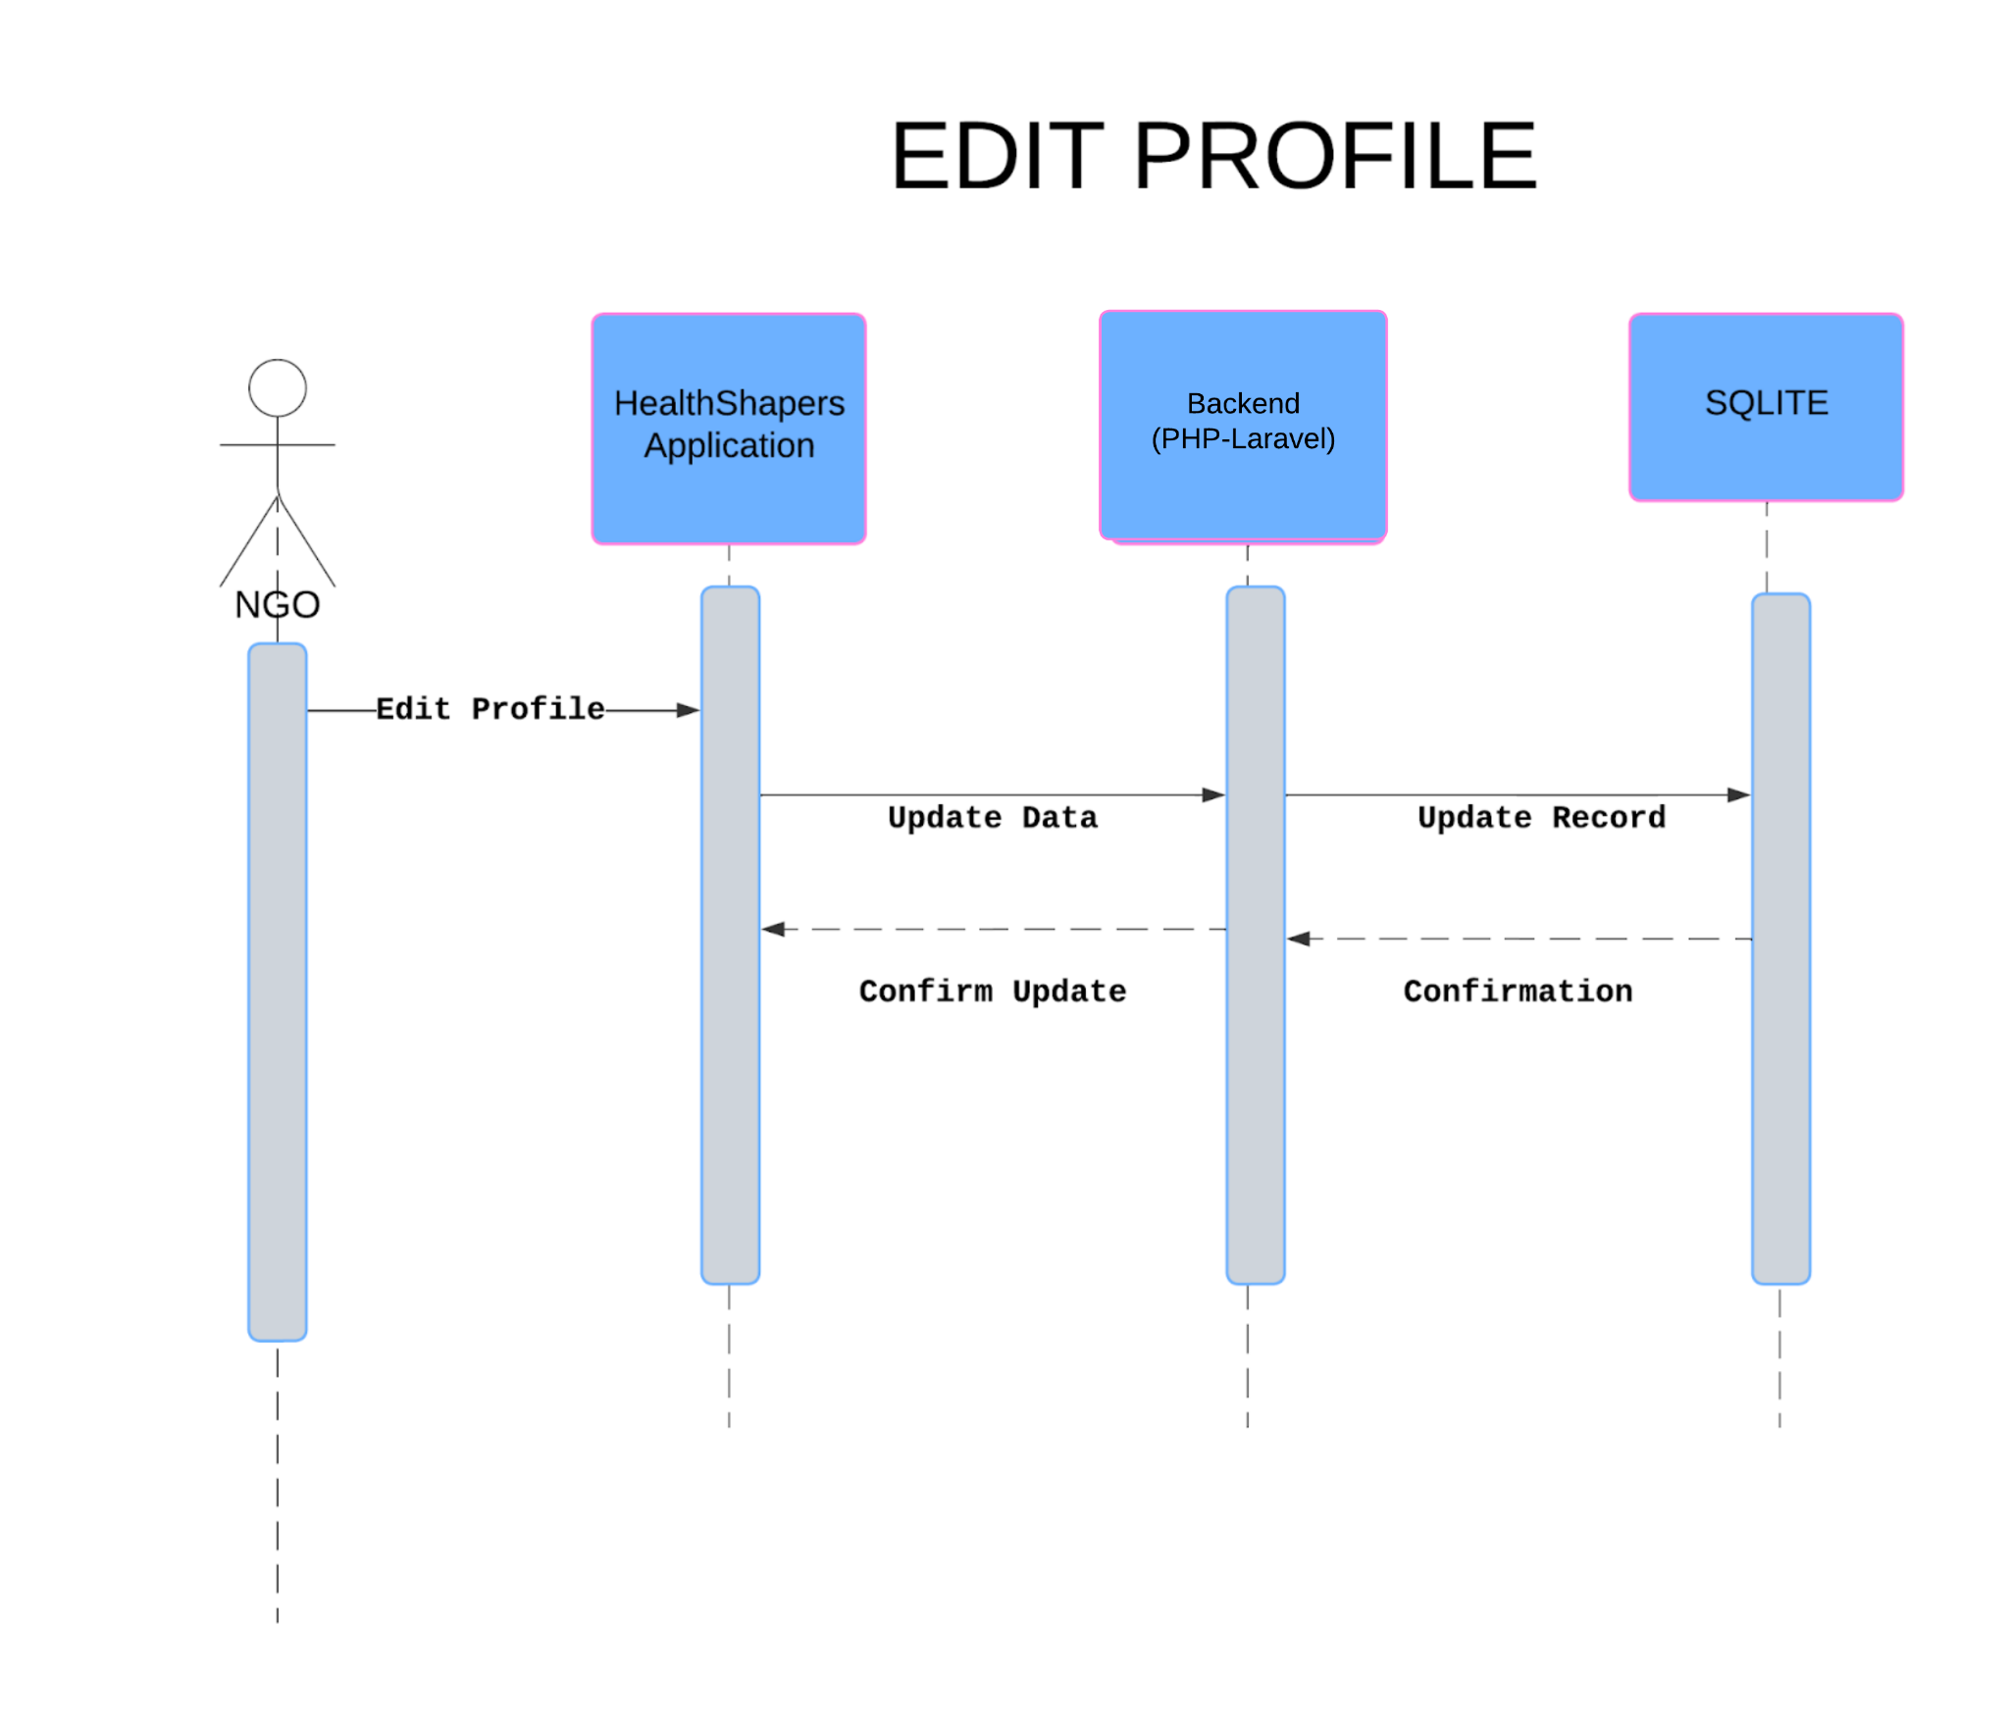

Settings

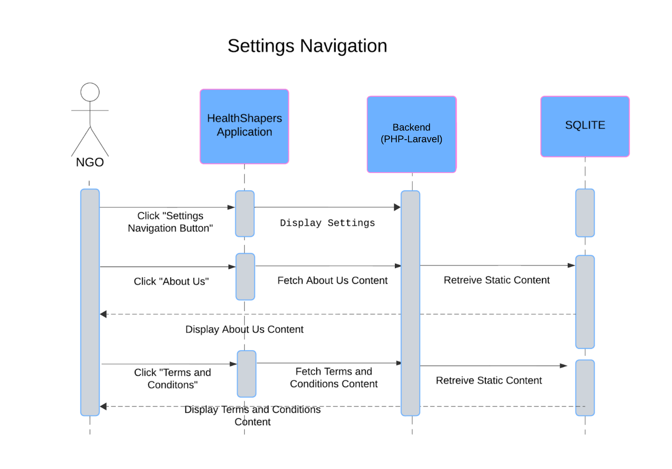

Logout

